Activity details
Activity Name |  |  | Venue
Support Worker

Overall activity description including agenda for activity arrangements

Number of Participants |  |  | Male: |  | Female: | Support Worker ratio:
Consent form drafted and attached |  |  |  |  |  |  | Yes | No
Risk assessment for this Activity is completed and attached |  |  |  |  |  |  | Yes | No

Itinerary
Start date |  | Depart Venue |  | Arrival venue
Finish date |  | Depart venue |  | Arrival Time

Overnight accommodation
Details:

Venue suitability assessed and risk management processes applied | Yes | No

Transport
Mode | Travel Timetable/Route | Certification Requirements | Yes | No
Bus |  | Bus with seatbelts.
Private car |  | Private Car requirements met such as insurance
Train |  | Handicap Accessibility
Boat |  | Certificate of operation and certificate of survey current.
Aeroplane |  | If commercial airline, no checks are required
Other

Items | Cost ex GST | GST of item | Details
Transport | $ | $
Venue | $ | $
Catering | $ | $
Other Costs | $ | $
Other Costs | $ | $
Cost for each Participant: TOTAL: | $ | $

Attachment 1
The following checklist is to assist you in identifying the appropriate equipment, hazards/risks and control measures to be considered prior and during an Innovative Community Participation Planning. They are not exhaustive lists and you may choose to add additional considerations.

Minimum equipment/facilities For any items not ticked, provide further information.
First aid kit suitable for activity
Emergency and first aid requirements and personnel in place for the duration of the activity
Communication system: e.g. mobile phone, phone line at location, walkie-talkies/UHF radio
Clothing suited to weather conditions (e.g. sun protection)
Drinking water (participants should not share drinking containers)
Fire restrictions have been checked with the local fire authority as appropriate
Permission has been obtained from property owners where the property will be traversed

Risk assessment
When planning the activity/excursion adhere to the Risk Management procedure and consider the following questions:
- Which Participants will be involved? | - What will the Participants be doing?
- Where will the Participants be? | - Who will be leading the activity?
- What will the Participants be using?
Hazards/risks | Example control measures
Consent | - Obtain participants/ Family/ Advocate consent, including relevant medical information.
Participants safety | - WWCC requirements met. (If applicable)
Participants safety | - Consider whether Participants will come into contact with people other than provider’s support team member (e.g. shared use of venues, use of public toilets) and how this will be managed.
Participants considerations | - Ensure that venues and facilities are accessible to all Participants
Participants considerations | - Refer to relevant participants management/behaviour plans or other records.
Participants considerations | - Seek advice from relevant staff (e.g. BPS Practitioner ).
Participants considerations | - When Participants with medical conditions are involved, ensure that relevant medical/emergency plans and medications are readily available.
Briefings | - Ensure that all supervisors are aware of the emergency contingency plans.
Briefings | - Brief support worker’s prior to departure regarding any potential hazards and safety controls.
Briefings | - Brief Participants prior to departure on any potential hazards and safety controls.

Details Risk Assessment

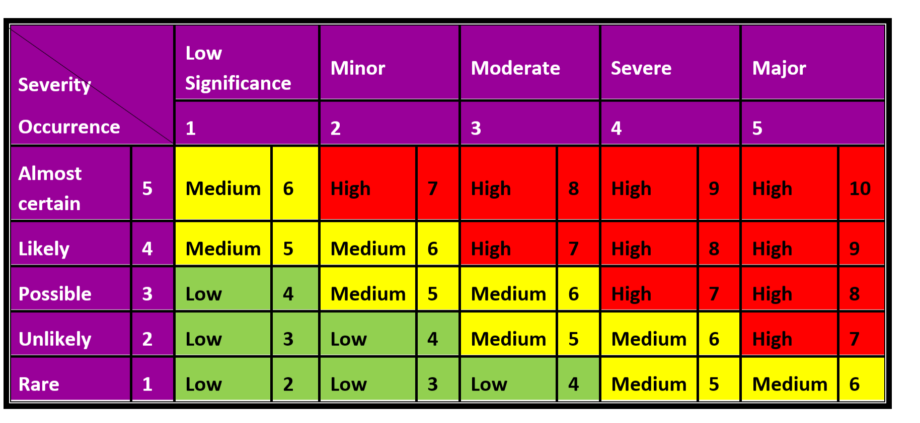
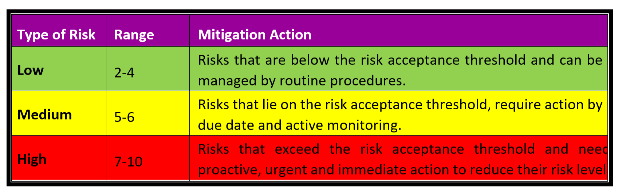
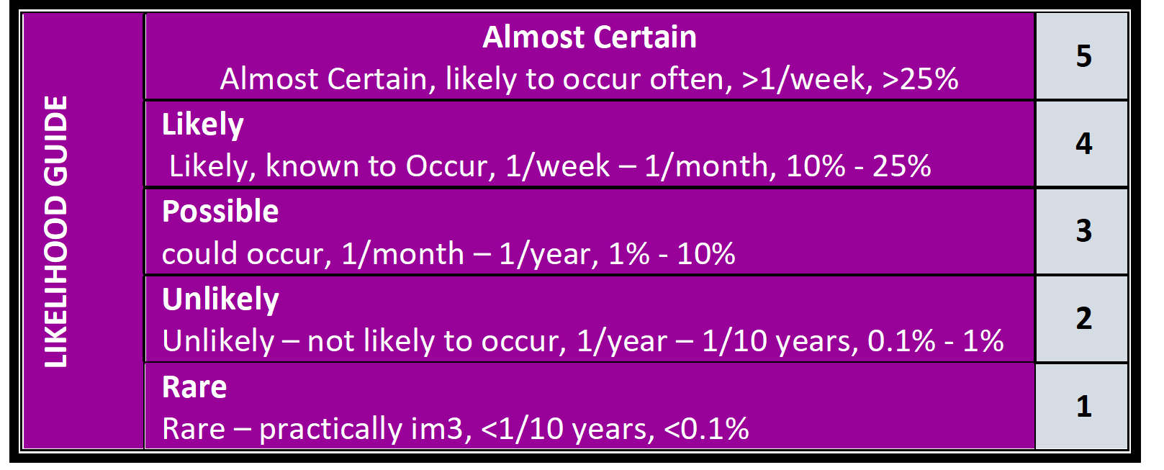

No. | Tasks or Activity | Issue/Hazard/Aspect | Risk/Impact | Consequence | Likelihood | RISK SCORE | Control Measures | Person Responsible | Residual Risks
 |  |  |  |  |  |  |  |  | Consequence | Likelihood | RISK SCORE

Communication of Form.101
Once completed, was this Form shared and communicated to:
- -All participants involved in the activity.
- -All families of participants? (If required)
- -All support staff involved in this activity?

